**Legal Notice:** This document contains privileged and/or confidential information and may not be disclosed, distributed or reproduced without the prior written permission of Datamola.

U1M6.LW.Star Schema Basics

#### Kiryl Bucha

Contents

1. Prerequisites 3

1.1. Passwords Index 3

1.2. Folder Paths Index 3

2. OLTP – Load External References – Normalization of Data 3

2.1. Task 01 – Install and expand load of external references T_Languages 3

2.1.1. iso-639-3.tab – Storage of Languages 4

2.1.2. iso-639-3-Macro.tab – Store of Links Between Macro and Individual languages 4

2.1.3. Installing scripts 4

2.2. Task 02 – Create load process for External references T_Countries 6

3. OLAP – Business analyses task 7

3.1. Task 03 – Solution concept – Business background 7

4. OLAP – Develop Star-Scheme and SnowFlake Scheme. 8

4.1. Task 04 – Develop Star-Scheme physical diagram 8

4.2. Task 05 – Develop SnowFlake physical diagram 8

# 1. Prerequisites

## 1.1. Passwords Index

|  |  |  |
| --- | --- | --- |
| Password Group | Login Name | Password |
| Operation System | root | “rootadmin” |
|  | oracle | “oracleadmin” |
|  |  |  |
| Oracle System | sys | “sysadmin” |
|  | system | “sysadmin” |
|  |  |  |
| Oracle Users | All DB users | “%PWD%” |
|  |  |  |
|  |  |  |

## 1.2. Folder Paths Index

|  |  |  |
| --- | --- | --- |
| Path Group | Path Description | Path |
| Operation System | Oracle RDBMS – BIN | /oracle/app/oracle |
|  | Oracle Inventory | /oracle/app/oraInventory |
|  | Oracle Database Storage | /oracle/oradata |
|  | Oracle Install Directory | /oracle/install |
| Oracle | ORACLE_BASE | /oracle/app/oracle |
|  | ORACLE_HOME | $ORACLE_BASE/product/11.2 |
|  |  |  |
| FTP | ftp Incoming Folder | **/ftp/incoming** |
|  |  |  |
|  |  |  |

# 2. OLTP – Load External References – Normalization of Data

## 2.1. Task 01 – Install and expand load of external references T_Languages

Description of External Resources:

|  |  |
| --- | --- |
| File Name | Path |
| iso-639-3.tab | …\Topic 06 - Star Schema Basics\External_References |
| iso-639-3-Macro.tab | …\Topic 06 - Star Schema Basics\External_References |

### 2.1.1. iso-639-3.tab – Storage of Languages

|  |  |  |
| --- | --- | --- |
| Name | Data Type | Comment |
| lng_3c_code | VARCHAR2( 3 CHAR ) | ISO 639-3 identifier |
| lng_2b_code | VARCHAR2( 3 CHAR ) | ISO 639-2 identifier of the bibliographic applications |
| lng_2t_code | VARCHAR2( 3 CHAR ) | ISO 639-2 identifier of the terminology applications code |
| lng_1c_code | VARCHAR2( 2 CHAR ) | ISO 639-1 identifier - common standard |
| lng_scope | VARCHAR2( 2 CHAR ) | Identifier of the language scope |
| lng_type | VARCHAR2( 1 CHAR ) | Identifier of the language type |
| lng_desc | VARCHAR2(200 CHAR) | Edonym Name of Language |

### 2.1.2. iso-639-3-Macro.tab – Store of Links Between Macro and Individual languages

|  |  |  |
| --- | --- | --- |
| Name | Data Type | Comment |
| macro_lng_code | VARCHAR2(3 CHAR) | LNG_ID: MacroLanguage - T_Languages |
| indiv_lng_code | VARCHAR2(3 CHAR) | LNG_ID: Individual Language - T_Languages |

### 2.1.3. Installing scripts

Path: …\Topic 06 - Star Schema Basics\lab_scripts\task01\

|  |  |  |
| --- | --- | --- |
| Path: | Folder | Description |
| ../ lab_scripts/task01 |  |  |
|  | /system | All system admin scripts:  Initial Tablespaces scripts  Initial Users scripts |
|  | /u_dw_common | Store common used objects |
|  | /u_dw_references | Store of DB references objects |
|  | /u_dw_ext_references | Cleansing store for External References |

**The Main Task** is to running preparing SQL scripts and install needed objects for load external reference T_Languages.

**Task Results:**

* Create sql scripts to show All created Tables and Views – Screenshot
* Create DataFlow: Sketch Diagram of loading external References (MS Visio, MS Paint, MS Word, etc.)
* Create sql: Showing result of data on next objects:
* t_localizations
* cu_languages
* w_lng_links
* cu_lng_scopes
* cu_lng_types

The Physical Diagram of T_Languages below:

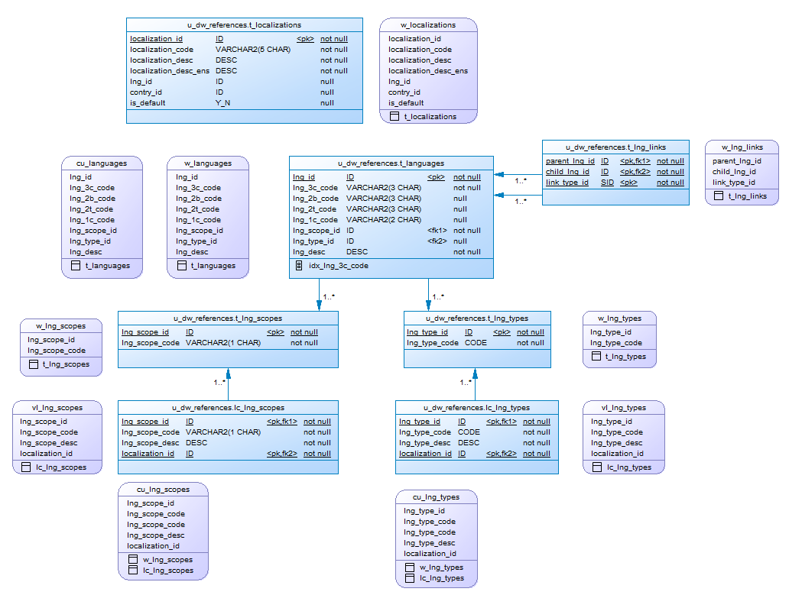

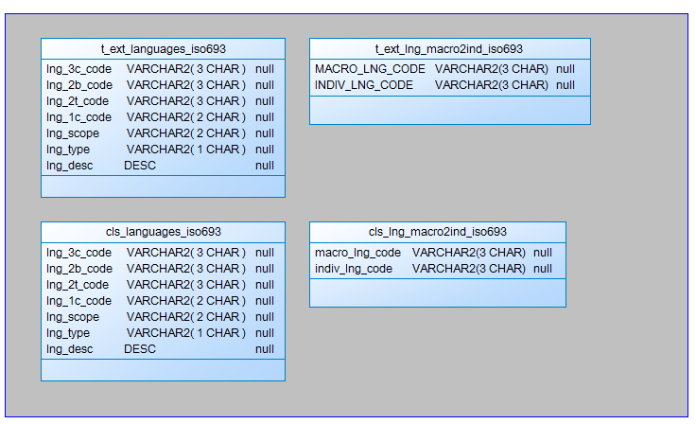

## 2.2. Task 02 – Create load process for External references T_Countries

Description of External Resources:

|  |  |
| --- | --- |
| File Name | Path |
| iso_3166.tab | …\Topic 06 - Star Schema Basics\External_References |
| iso_3166_geo_un.tab | …\Topic 06 - Star Schema Basics\External_References |
| iso_3166_geo_un_contries.tab | …\Topic 06 - Star Schema Basics\External_References |
| iso_3166_groups_un.tab | …\Topic 06 - Star Schema Basics\External_References |
| iso_3166_groups_un_contries.tab | …\Topic 06 - Star Schema Basics\External_References |

**The Main Task** is to develop SQL scripts and install needed objects for load external reference T_Countries.

**Task Results:**

* Create SQL scripts to show All created Tables and Views – Screenshot
* Create DataFlow: Sketch Diagram of loading external References (MS Visio, MS Paint, MS Word, etc.)
* Create SQL: Showing result of data on main objects:
* Prepare The Physical Diagram of T_Countries

# 3. OLAP – Business analyses task

Create any business analyses task for interesting for your business. The main idea is to use next main dimension:

* Time
* Geo-Location – T_COUNTRIES

## 3.1. Task 03 – Solution concept – Business background

**The Main Task** is to create Solution concept of yours any business analyses task. You should use Developing Model, that described on MTN.NIX.07.Oracle DB.DWH_courseware06_Star Schema Basics.docx.

**Task Results:**

Create Solution Concept document, which contained next chapters:

Overview

Business Background

Benefit

Requirements

Business Requirements

Technical Requirements

Solution Sketch

Source Tables structure

Summarize Data Plan

# 4. OLAP – Develop Star-Scheme and SnowFlake Scheme.

## 4.1. Task 04 – Develop Star-Scheme physical diagram

**The Main Task** is to create Star Physical diagram and Logical diagram of solution.

**Task Results:**

Create document, which contained next chapters:

* Physical diagram
* Logical diagram

## 4.2. Task 05 – Develop SnowFlake physical diagram

**The Main Task** is to create SnowFlake Physical diagram and Logical diagram of solution.

**Task Results:**

Create document, which contained next chapters:

* Physical diagram
* Logical diagram